Study to examine agricultural consumption in Maharashtra

Agency: Maharashtra State Electricity Distribution Company Ltd. (Mahavitaran)

2015 - 16

Agricultural loads are a large part of MSEDCL consumers, comprising 25 to 30% of the total energy consumption. There are several issues with the current situation with regard to agricultural energy consumption measurement. Though 67% of the pumps are supposed to be metered, and the rest billed on a flat rate, metering is in fact in a poor state for all consumers. Over the years doubts have been expressed over agricultural energy consumption numbers. There have been repeated demands from the MERC for a rigorous study to determine specific consumption [Ref: Case 19 of 2012, Case 100 of 2011].
Hence the distribution company, Maharashtra State Electricity Distribution Company Ltd. (MSEDCL), commissioned a study to develop a protocol for energy consumption estimation in the state.
The study was conducted on a sample set of 100 feeders in the state. 15 engineering colleges across the state of Maharashtra were engaged in a collaborative exercise (see table below)
The estimated energy consumption for 2015-15 resulted in changes in MSEDCL energy accounting, and the study was quoted and used in regulatory commission hearings: Case No. 48 of 2016 (November 2016), and Case No. 176 of 2016 (November 2017).
Colleges involved in the project
• Mauli College of Engineering and Technology, Shegaon
• Government engineering college of Aurangabad, Aurangabad
• Someshwar Engineering College, Someshwar
• Karmayogi Engineering College Shelve, Pandharpur
• Rajarambapu Institue of Technology, Islampur, Sangli
• Government College of Engineering, Jalgaon
• BAIF Development Research Foundation, Pune
• MBES, College of Engineering, Ambajogai
• Nagesh Karajagi Orchid College of Engineering & Technology, Solapur
• SGGS Institute of Engineering and Technology, Nanded
• K. K. Wagh Institute of Engineering Education & Research, Nasik
• CoEP, Pune
• VNIT, Nagpur
• Government College, Arvi
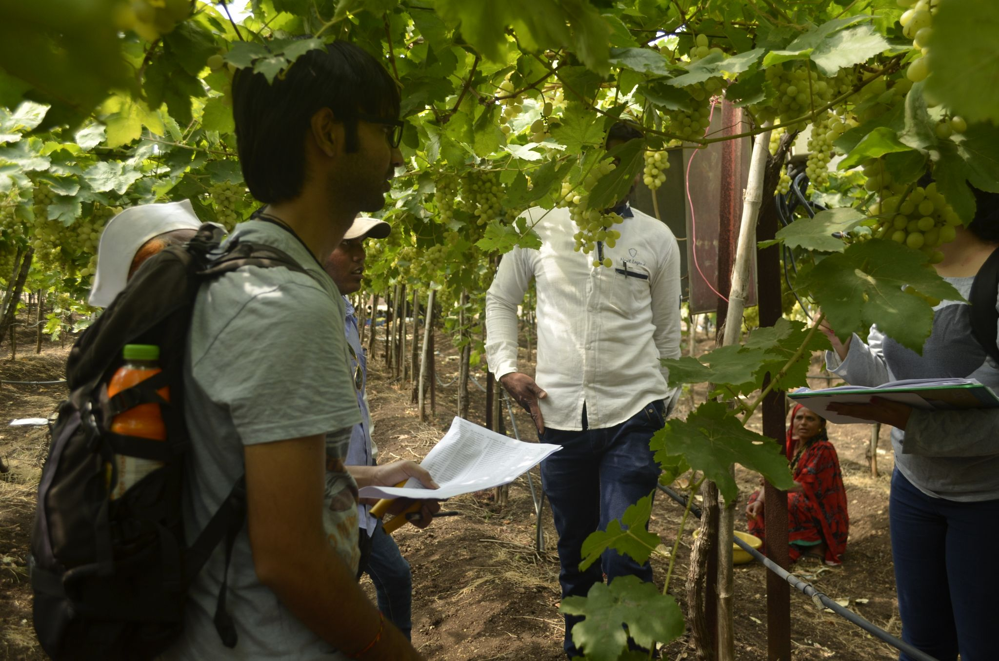
IIT Bombay team surveying farmers on the Old Dawachwadi feeder, Niphad block, Nashik

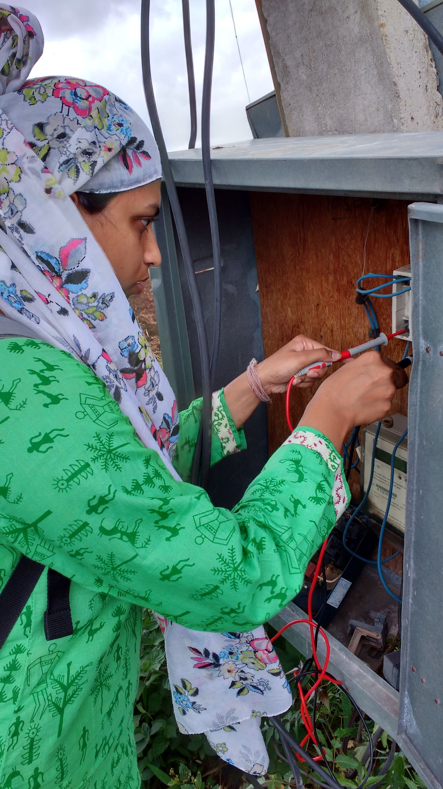
Power measurements at a pump

